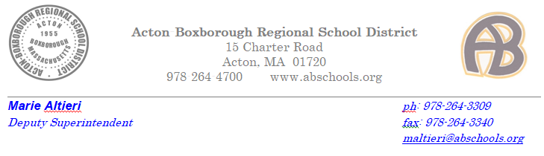Dear Acton-Boxborough Employees and Substitutes,
Massachusetts requires all public school employees and substitutes to complete a one-time national criminal background check. Unlike CORI, this check will examine criminal activity in all states including Massachusetts. If you have been fingerprinted by another school district in Massachusetts, please notify Tammy Costello at tcostello@abschools.org, and she will ask for a fingerprinting suitability letter from that district. In that case, you will not need to be fingerprinted again.
If you have not been fingerprinted, you will need to be fingerprinted before you start working at ABRSD. The fingerprint process requires two steps. The first step is to register for an appointment to have your fingerprints taken. The second step requires your physically going to a location to have your fingerprints taken. Your fingerprint result will be emailed aato Human Resources directly. To register for an appointment:
- Please visit the IdentoGO website www.l1enrollment.com/locations/?st=ma
- The website outlines the current list of fingerprinting locations. When making your appointment, you will be asked your zip code. From that information, the MorphoTrust sites closest to you will be listed first. Once you have chosen the location you would like to visit, click on the link to register for an appointment. There are many locations throughout Massachusetts and, in addition to weekday hours, they offer evening and Saturday hours as well.
- The fee is $55 for staff who hold a DESE license and $35 for those who do not hold a DESE license. You will need to pay with a credit card while online. Even if you are currently in an assistant position, if you have a DESE teaching license you will need to register as a licensed educator and pay the $55 fee.
When you are asked to provide a “Provider ID” please use the code for Acton Boxborough Regional School District: 06000000
- Lastly, please print the confirmation page and note the identification you will need to bring with you to the fingerprinting center.
Should you have difficulty registering for your appointment, please contact Tammy Costello in Human Resources at x3260 or via email. Thank you very much for your cooperation in completing this procedure.
Sincerely,
Marie Altieri
Deputy Superintendent
Acton Boxborough Regional School District

